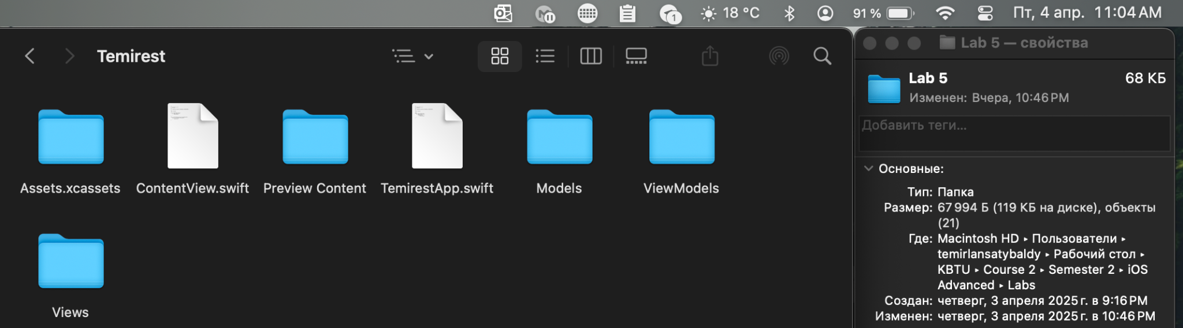

Sorry I spelt and forgot to upload in github. There is you can see time of last changes